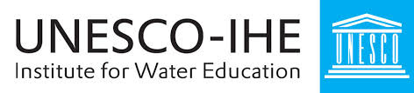
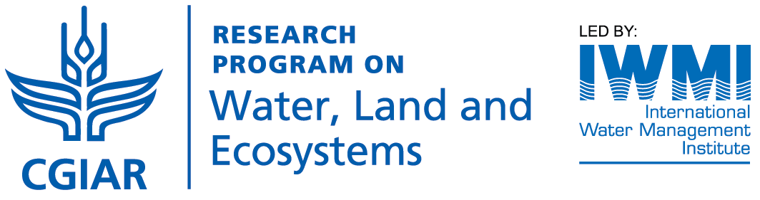

WLE and UNESCO-IHE Partner Roundtable Meeting Agenda

June 14, 2016
Time | Agenda Item
11.30 – 12.00 | Registration/Coffee/Introduction of participants
12.00 – 12.15 | Welcome and introduction  Rector of UNESCO-IHE
12:15 – 12:30 | Introductory presentation on WLE  Meredith Giordano, Acting Program Director, WLE
12:30 – 13:15 | Panel discussion: Why sustainability matters for agricultural development  Moderator: Deborah Bossio  Panelists: Claudia Ringler (WLE/IFPRI), Jan Hijkoop (DGIS), Joan Kagwanja (WLE SC), Ken Irvine (UNESCO-IHE)
13.15 – 14.15 | Lunch/Poster walk around
14.15 – 15.45) | Working groups on specific thematic areas:  - Improving water productivity through a confluence of policy, technical and institutional investments - Jennie Barron (WLE)/Jippe Hoogeveen (FAO)  - Supporting rural-urban linkages for a more sustainable circular economy - Miram Otoo (WLE)/ René van Veenhuizen (RUAF)  - Regenerating degraded natural resources and ecosystem services - Debbie Bossio (WLE)/ Rik van den Bosch (ISRIC)  - Enhancing resilience to climate change and other shocks - Claudia Ringler (WLE)/ Neno Kukuric (IGRAC)
15:45 – 16:15 | Report back on groups and discussion ed by Dr. Gretchen Daily
16:15 -16:30 | Summary and wrap up
16:30 – 17:30 | Closing and reception

