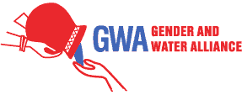
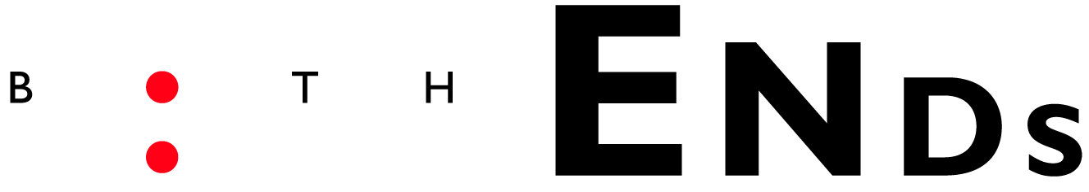
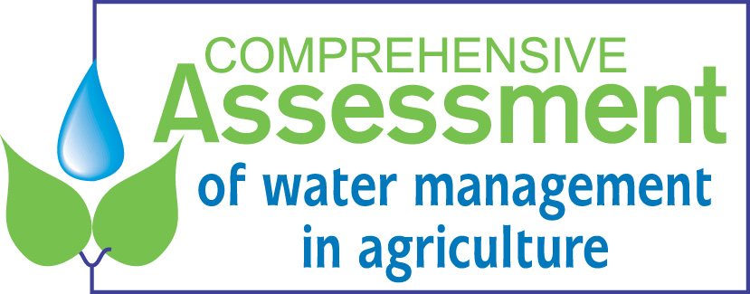
`A minimum agenda for effective
gender mainstreaming in water management’

This agenda needs your input.
Please share your expertise, views and suggestions!
We invite you to join our effort to define a minimum agenda for practitioners, policy makers and researchers to effectively mainstream gender in water management.

Please have a critical look at the minimum agenda and fill out this short questionnaire and leave it at either the stands of CA/IWMI/CO, the Women’s Coalition or the Freshwater Action Network. We also invite you to come to the Women’s Coalition stand on 19th, 20th or 21st of March at 13.00 for an open discussion on this agenda and follow-up steps. Thank you very much in advance!

----------------------------------------------------
Your name: _______________________________________________________________________
Organisation: ______________________________________________________________________
E-mail address: ____________________________________________________________________
Profession: _______________________________________________________________________

- Do you agree or disagree with what is suggested in this minimum agenda for you as a practitioner, policy maker, researcher or gender expert? Please give your opinion and additional suggestions.
_________________________________________________________________________________
_________________________________________________________________________________
_________________________________________________________________________________
_________________________________________________________________________________
_________________________________________________________________________________
_________________________________________________________________________________
_________________________________________________________________________________
_________________________________________________________________________________
_________________________________________________________________________________
_________________________________________________________________________________
_________________________________________________________________________________
_________________________________________________________________________________

- Do you have any experience or case that demonstrates the positive difference a gendered approach makes to water management in agriculture by increasing efficiency and sustainability?
- If yes, is it documented? Where?_________________________________________________
__________________________________________________________________________
- If not documented, would you like to do this?_______________________________________

We are very happy to receive your input even after the forum. Please send us your comments, suggestions and relevant cases to either:
- Joke Muylwijk, Gender and Water Alliance: joke.muylwijk@chello.nl
- Domitille Vallee, Comprehensive Assessment: d.vallee@cgiar.org
- Annelieke Douma, Both ENDS: ad@bothends.org

To look at the outcomes of the online discussion, the expert meeting and the survey please visit:
http://203.115.28.178:8080/display/Fgender/Gender+Mainstreaming+in+Water+Management+for+Agriculture

