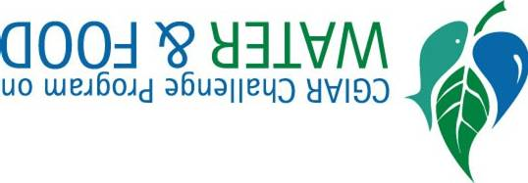
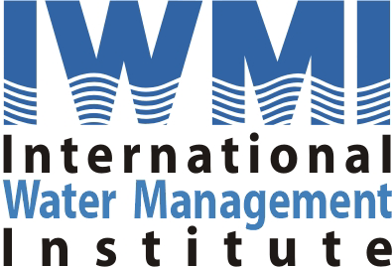




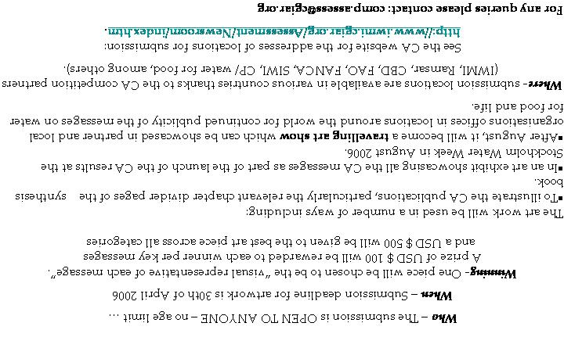

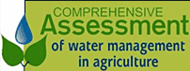

GLOBAL ART COMPETITION:
Using artwork to present our messages on water for food
Communicating without words to learn about water & agriculture through a
Why- The CA has been critically evaluating the benefits, costs, and impacts of the past 50 years of water development, the water management challenges communities are facing today, and solutions people have developed. The results will support better investment and management decisions in water and agriculture in the near future and over the next 50 years. The CA now wants to communicate its messages to a wide audience through innovative ways- such as art.

What- We are asking for submissions of artwork that is 2 dimensional or flat in format but there are no restrictions on art style (can be print, sketch, paint, cloth, cartoons etc).
Artwork must reflect one of the eighteen categories of messages (see inner pages for messages)…

Other details on back of flyer…

Each piece of Artwork should be created based on one of the following key messages from the CA, which are:

- Water for food, water for life: Good water management in agriculture is necessary for healthy environment and to provide good health and better incomes. There will be a need for more water for agriculture to reduce hunger and feed a growing population.

- Education, capacity building and awareness-raising are three fundamental stepping stones toward better water management in agriculture.

- Think about how much water is needed to produce your food. Food demand drives water demand. Choices about what we eat and how and where we produce it have enormous implications for water resources, even if global climate changes.

- Water for farming to fight poverty: Access to water for crops, animals and fish is a proven ingredient to fight rural poverty. Small scale, affordable water technologies can improve livelihoods and food security. These include low cost drip systems, pumps, community water harvesting...But technologies alone is not enough, investments in people and their institutions is also needed.
- Many people have a stake in water for food and life. Informed negotiations among multiple interest groups are required to strike tradeoffs between different interests, and innovative institutional arrangements to ensure the application of decisions.

- Agriculture can support healthy ecosystems. Producing food and fibre through agriculture has harmed natural ecosystems in the past; but it can be prevented. In agro-ecosystems, we can achieve the goals of producing enough food, improving people's livelihoods in a healthy environment.

- Grow more food with less water: with careful management and proven approaches, people can get more crops, fodder and income, and leave water for other uses. With targeting, the poor can benefit from water productivity gains.

- Unlocking the potential of rainfed agriculture: Up-grading rainfed agriculture is a high priority action to increase productivity and reduce poverty. On-farm water harvesting, supplemental irrigation, soil-crop management and improved germplasm can boost productivity in dry-farming poverty hot spots of the world.

- Re-inventing irrigation: irrigation must improve for more food and a healthier environment. The era of rapid expansion of irrigated agriculture is over: a major new task is adapting yesterday’s irrigation systems to tomorrow’s needs.
- Groundwater boom and bust? The groundwater boom, digging deeper for more water has been a huge benefit for small farmers. But the boom is turning to bust; the future may be dry wells, unless groundwater can be sustainably managed.

- Feed the cities with wastewater – grow more food and waste less water: One persons waste is another person’s wealth – use wastewater productively and be more careful with health risks.

- Freshwater fisheries provide jobs to millions of poor people worldwide and feed many tens of millions more. But, this important resource is not well looked after. Governments and business leaders need to do a better job by thinking about how much water fisheries need and taking steps to provide this.

- Livestock keeping is a key by which the world’s rural poor escape poverty. Livestock depends on water, but when poorly managed, contributes to degradation and contamination of water resources. There is growing demand for meat products and the potential conflicts with other users thus livestock-water considerations need to be better understood.
- Rice: feeding the billions while providing unique ecosystem services, such as a home for diverse plants and animals, as well as culture.

- Conserving land, protecting water: Smallholder agricultural systems can prevent erosion by protecting the water. Soil conservation ensures better water retention by the plants.

- River Basins are squeezed: In many basins, water resources are overcommitted and rivers hardly reach the sea. Competition for water sharply increases with growing and uncoordinated water abstraction for varied human uses from up to downstream. New development in these cases means a net loss to other users and to the environment.

- Equity and Gender matters in Water and agriculture Projects! Including socio-cultural diversity of communities leads to sustainability. Men and Women of different age groups, classes and ethnicity are triggers of development.

- Sound water management for people’s health. Multiple-use systems (systems integrating water management for domestic use, crop production, aquaculture, agro-forestry, and livestock) are effective to reduce poverty and improve hygiene.

