Extent and significant use of low quality water in agriculture: The case of Addis Ababa Catchments the upland of the Awash Basin1

Girma Tadesse

International Livestock Research Institute

P.O. Box 5689, Addis Ababa, Ethiopia, Email: g.taddesse@cgiar.org

Don Peden

International Livestock Research Institute
PO Box 5689, Addis Ababa, Ethiopia, Email: d.peden@cgiar.org

Peter McCornick

127, Sunil Mawatha, Pellawatte, Bataramulla, Sri Lanka, Email: p.mcronick@cgir.org

Summary
The daily waste generation in Addis Ababa catchments is estimated about 0.252kg/capita/day and 65 % (1,482m³)/day of municipal waste is collected. There is an increasing concentration of heavy metal pollution, coliform and pathogen pollution in the surface and ground water. The nitrate concentration in surface water is higher than the accepted normal concentration of 10 mg/l. Irrigation with polluted water increased accumulation of heavy metals in the soil. Consequently, irrigating with polluted Akaki River has increased As and Zi considerably high.

Introduction
Next to Oxygen, water is the most important substance for human existence (Melese Tafese 1998). Freshwater rivers, lakes and groundwater are used to irrigate crops, to provide drinking water, and to act as a sanitation system. Water sources have increasingly become polluted with municipal sewage, industrial waste, industrial toxics, heavy metals, fertilizers, chemicals, radioactive substances, land sediment, and oil. For down streams, which lack proper water treatment and filtering facilities, public health is seriously threatened by polluted drinking water (Zewdie Abate 1994). Lead poisoning is also a serious health problem resulting from corroding water pipes (Tamiru Alemayehu et al., 2003). The growth in toxics, radioactive, heavy metals and chemicals in the water supply is alarming (Fisseha Itanna 2002). These pollutants cause long-lasting damage and is life threatening. Wastewater is used as a source of irrigation water as well as for drinking (Alemtsehaye Biru 2002). Pesticides in agricultural runoff also poison plant and animal life. In addition to the process of desertification, pollution is also reducing the volume of safe fishing, irrigation, and drinking water. Similarly, organic pollutions and water excreta based diseases are on the rise in Ethiopia. In some localities sludge water and human faces and other are also dumped to these rivers. One surprising aspect of these catchments is communities use the polluted/waste water from these rivers for irrigation (Waltainformation 2004). Some studies indicated that 40% of the vegetable supplied to Addis Ababa city and animal feed comes from the suburb directly irrigated by these water or fields flushed from waste water during the heavy rainy season or during the dry season. All rivers in the city are generally loaded with solid wastes. During dry periods very low flow levels characterize the rivers.

Addis Ababa City and Addis Ababa Catchments

Location- Addis Ababa is the diplomatic capital of Africa. Addis Ababa is located in the heart of the country surrounded by mountains. Addis Ababa covers about 540 Km² of which 18.2 Km² are rural. The city lies at the foot of the 3,000 meters high of Entoto Mountains (Figures 1 & 2). Addis Ababa enjoys a mild, Afro-Alpine temperate climate. Besides the residents of rural parts of Addis Ababa, the city dwellers also participate in animal husbandry and cultivation of gardens (Addis Ababa City Council 2004).

Drainage-Big and Little Akaki Rivers, with their different tributaries, drain the city from north to south.
Big Akaki (900 km2) and Little Akaki basin has a catchment area of about 540 km2 (Figure 3). The streams serve as natural sewerage lines for domestic and industrial wastes, hence making them known for their offensive odor.
Eutrophication process in the streams is a result of water pollution.
Population-The population of the city is over 3 million live in 10 sub-cities and 204 districts divided for administrative purposes. The ten sub-cities are: Addis Ketema, Lideta, Cherkos, Yeka, Bole, Akaki Kaliti, Nefas silk, Kolfe Keranio and Gulele each with an average of 300,000 people

Water Supply -Nearly 80% of Addis Ababa population relies on good quality surface water for drinking, fire fighting and sewage disposal. Many industries as well as electrical power plants and some farmers who irrigate or water livestock all depend on large quantities of good quality surface water (Ijgneh Sime 1998). However, any use of surface water has the potential to affect its quality. In the year 2010 the requirement for potable water to satisfy for all demands plus unaccountable for looses was estimated to average 1105000m/day (Table 1). There are three dams with the supply of 173,000 m³/day, springs 10,000 m³/day and Akaki wells supply 30,000 m³/day.
Table 1. Potable water demand for Addis Ababa city.
Year | Population Projection | Potable water  Demand (m ³/day)
2004  2010  2020 | 3060000  3830000  5570000 | 380000  565000  1105000

Source: Ijgneh Sime 1998

Dry Waste- In adequate dry waste management has resulted in the accumulation of waste on open lands, in drains and in the living area of many people, causing a nuisance and foul-smelling pools, environmental pollution through leaches from piles (water and soil pollution) and burning of waste (air pollution), clogging of drains, and the possible spread of diseases. Unattended piles of waste are a breeding place for insects and rats (Tadesse Kuma 2004). The daily waste generation is estimated about 0.252kg/capita/day, 65 % (1,482m³)/day of municipal waste is collected. The rivers are widely used as disposal sites (Addis Ababa City Council 2004). The management of solid waste needs a broad approach, that is the cooperation and integration of sectoral government institutions, nongovernmental organizations, and community organizations to overcome the management responsibility (Melese Tafese 1998).

Surface and ground water pollution- All streams are free from pollution in the upper part, however the water quality at the lower part of the river deteriorates gradually caused by organic pollution from Domestic and municipal wastes exacerbate quality of water during the dry season when the flow of most streams is low (Tesfaye Berhe 1988). Many industries are discharging industrial effluent in the Little and Greater Akaki Rivers, which finally join the Aba Samuel Reservoir. This reservoir is now serving as an oxidation pond. Based on Zewdie Abate's (1994) report the biochemical oxygen demand (BOD) in Little Akaki and Greater Akaki was 4665 kg/day and 1000 kg/day, respectively (Figure 4). About 175kg/day phosphate and nitrogen is added to Aba Samuel Reservoir. About 25000 cattle and 15 people utilize the water. Tamiru Alemayehu et al., (2003) showed that there is an increasing concentration of heavy metal pollution, coliform and pathogen pollution in the surface and ground water (Table 2). The nitrate concentration in surface water is higher than the accepted normal concentration of 10 mg/l (Table 3). Nitrates are found naturally in certain vegetables, and added as preservatives to some meat. Nitrates are also present in soil as part of the nitrogen cycle and are important for plant growth. Field application of commercial fertilizers and manure increases soil nitrate levels for crop production. Excess nitrates in soil can increase the risk of contamination of groundwater. Spreading manure or commercial fertilizers at rates matching plant needs (based on soil tests and manure analysis) will reduce the risk of contaminating the groundwater. Methemoglobinemia (also known as blue baby syndrome) is the only health condition widely accepted as being directly related to drinking water high in nitrates. Methemoglobinemia may occur in infants under one-year of age who drink water or formula made with water that has nitrate levels greater than 10 mg/L measured as nitrate-nitrogen. Excess nitrate in drinking water is only one of several possible causes of the disorder.

Table 2. Mean concentration of heavy metals (ppb) and pH in Addis Ababa Catchments.

 | Streams | Springs | Boreholes
Heavy metals |  | Part per billion (ppb)
pH  Mn  Cr  Ni  As  Pb  Zn | 7.72  2187.44  4.24  9.03  1.2  0.00  0.00 | 6.61  29.88  1.84  0.32  8.44  4.64  3.05 | 8.62  5.14  1.30  0.51  0.44  16.58  35.25

Source: Tamiru Alemayehu et al., 2003

Table 3. Mean coliform count and nitrate concentration in surface and ground water.

Sources | Coliform Count/ml | Nitrate  Concentration (mg/l)
Streams  Springs  Storm drain  Boreholes | 743  320  18940  83 | 270.1  419  na  0.5

Source: Tamiru Alemayehu et al., 2003

Agricultural Production and Pollution
Hygiene and Environmental Health Protection Department Head with the Bureau reported that vegetables including Cabbages, Salad, Carrot, Tomato, Green Paper and Onion produced through irrigations from river waters polluted by toxic and waste material from factories and households was posing serious endanger to the health of the resident of the City (Waltinformation 2004). Vegetables grown at environmentally contaminated sites in Addis Ababa could uptake and accumulate metals at concentrations that are toxic to human health. Cabbage was in general the least accumulator of metals/metalloids. Lettuce and Swiss In a few cases, As, Cr, Fe and Pb in these vegetables have surpassed maximum permitted concentrations (Figure 5) The intake of most of the metals constitutes less than 10% of the TMDI (theoretical maximum daily intake) at present, and hence health risk is minimal. But with increase in vegetable consumption by the community the Situation could worsen in the future. (Fisseha Itanna 2002).

Soil Pollution- Irrigation with polluted with heavy metal increases accumulation of heavy metals in the soil. Consequently, irrigating with polluted Akaki River has increased As and Zi considerably high (Figure 6).

Recommendation

- Compressive assessment is needed to evaluate the water pollution of Addis Ababa Cathcment.
- Use of wastewater for irrigation should be studied thoroughly on the River Awash Basin.
- The impact of wastewater utilization on human health and livestock/crop should be studied.
- The riverine system of Addis Ababa Catchments should be reestablished.
- The impact of Deforestation of upper Awash Basin should be assessed.
- For the sake of saving natural habitat there should be a controlling mechanism to control and stop dumping any wastes in the Addis Ababa streams and springs that gradually deteriorate the water in the Awash River Basin.
- We recommend the Second Phase of CA project to launch a project Proposal entitled “Desertification, land and water degradation of Awash River Basin Challenge to Djibouti and Ethiopia and North Western Part of the Horne of Africa.

References

Addis Ababa City Council 2004 http://www.ethiopar.net/English/basinfo/infoadds.html.
Alemtsehaye Biru. 2002. Assessment of the fertility and pollution status of irrigated vegetable farms around Addis Ababa City Agricultural Office. Final Report. Addis Ababa, Ethiopia.
Fisseha Itanna. 2002. Metals in leafy vegetables grown in Addis Ababa and toxicological implications. Ethiop.J.Health Dev. 16 (3): 295-302.
Melese Tafese. 1998. Solid Waste Management and the Role of Community Participationin Addis Ababa: With Reference of Two Kebeles in the Slums of Merkato Area. Addis
pages).
Tadesse Kuma 2004. Accounting for Urban Environment www.ictp.trieste.it/~eee/Workshops/smr1597/Kuma_1.doc)
Tamiru Alemayehu, Solomon Waltenigus and Yirga Tadesse. 2003. Surface and ground water pollution status in Addis Ababa, Ethiopia http//:www.un.urbanwater.net/cities/addababa.html.
Tesfaye Berhe. 1988. The Degradation of the Abo-Kebena River in Addis Ababa. M.Sc.
Thesis, Addis Ababa University (102 pages) http//: www.ictp.trieste.it/~eee/Workshops/smr1597/Kuma_1.doc
Waltainformation 2004. Vegetables Cultivated Along City's Polluted Rivers Said Posing Danger To Health http://www.waltainfo.com/EnNews/2003/Mar/18Mar03/Mar18e7.htm
Zewdie Abate. 1994. Water Resources Development in Ethiopia: An Evaluation of present and future planning concepts. Ithaca Press Reading. UK.

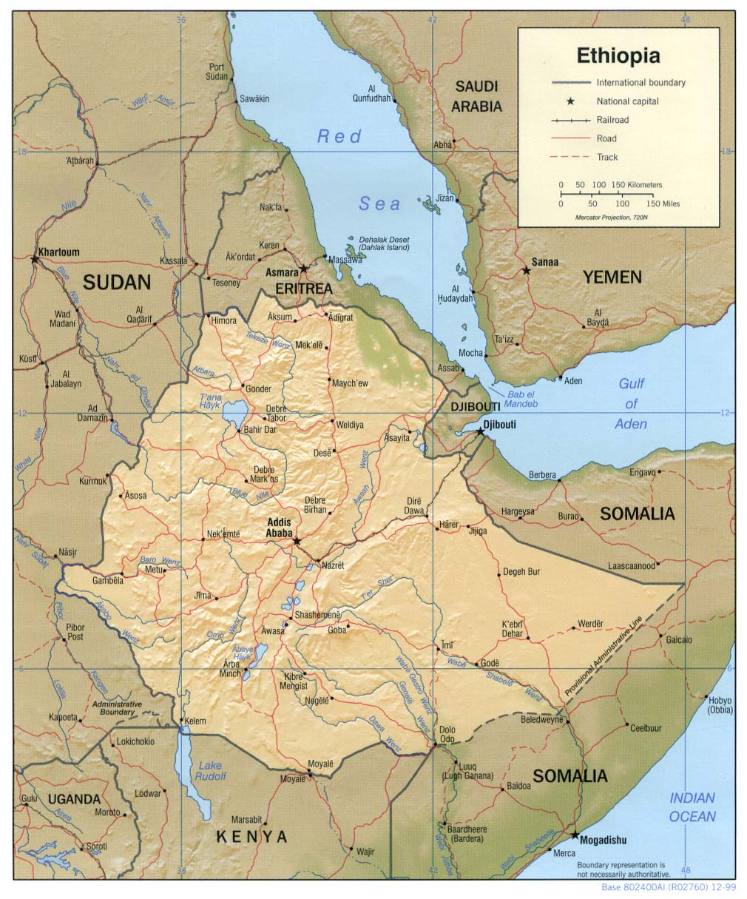

Figure 1. Map of Ethiopia
(Source: http//: www.un.urbanwater.net/cities/addababa.html)

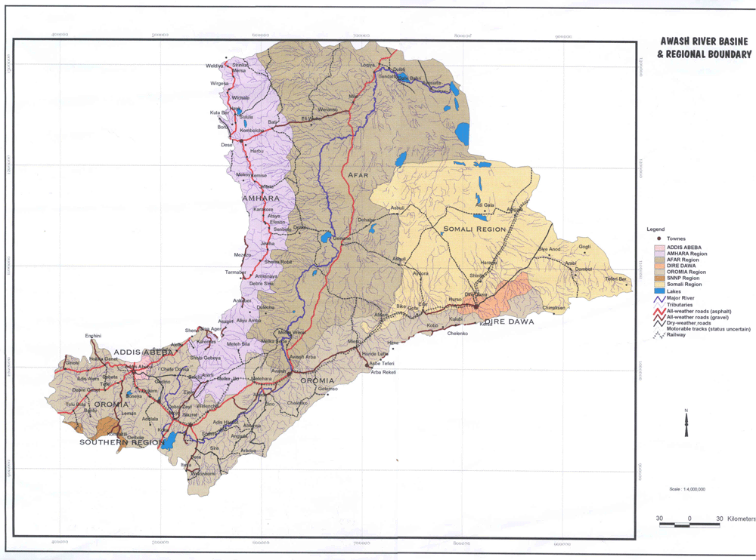
Figure 2. Awash River Basin (Source: Future Challenges of Awash Basin unpublished data of CA project 2003-2004).

Figure 3. Addis Ababa Catchments with main drainage system. (Source: http//: www.un.urbanwater.net/cities/addababa.html)

1 Contribution to CA Project in Ethiopia-Community-Based Irrigation in Ethiopia: Strategies to enhance human health, livestock and crop production, and natural resources management. International Water Management Institute (IWMI), International Livestock Research Institute (ILRI), Mekelle University (MU) and Ethiopian Agricultural Research Organization (EARO).

